**HTML Tutorial: Inline & Block Elements | Web Development Tutorials #9**

In the last tutorial, we have discussed forms and input tags. Here, we are going to understand what are **inline**and **block**elements. Let us start this tutorial by making a new file as *tut9.html*and adding the basic boilerplate of HTML. Then put the title as “Inline and Block Elements” in the <**title**> tag.

Inline elements are those elements which only occupy the space bounded by the tags defining the element, instead of breaking the flow of element. On the other hand, block-level elements take up the entire space of its parent element. Let us understand this with an example-

If we write any text in the paragraph tag like this-

<p>This is a paragraph</p>

<p>This is also a paragraph</p>

Copy

OR

<p>This is a paragraph</p> <p>This is also a paragraph</p>

Copy

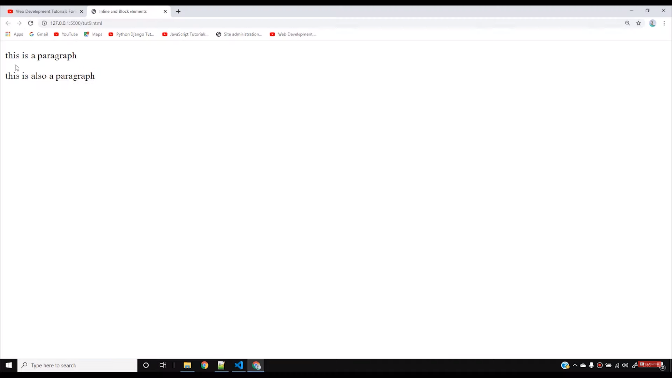

In both the above examples, we will see the output in both different lines, not in the same line. We want both the texts in the same line but it is not so. Can you think why?

It is because the paragraph tag is a **block element.**TheBlock element means that it will take the full width of a single line and does not allow any other content to fit in it. But, if we write both the texts between the <span> tags like-

<span>This is a paragraph</span> <span>This is also a paragraph</span>

Copy

Then we see that both the texts will appear in the same line. It is because the <span> tag is an inline element. It allows all the elements in the same line.

To understand it more, we can take the help of CSS by applying the border. However, you need not worry about the border as it is a part of CSS. I’m using this just for the case of an example.

<p style= “border: 2px solid, red;”>This is a paragraph</p> <p style= “border: 2ox solid blue;”>This is also a paragraph</p>

<span style= “border: 2px solid red;”>This is a span</span> <span style = “border: 2px solid red;”>This is also a span</span>

Copy

After testing the above code in the live server, you will know the main difference between inline and block elements.

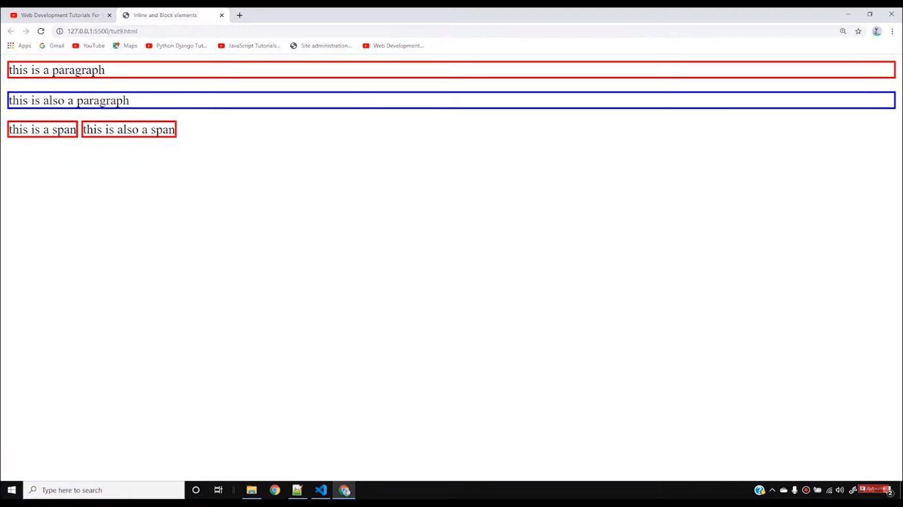

The above example shows how inline elements will take only its portion of text whereas the block element will take the whole width of the line. You will understand it more with the help of different colours through CSS. Anchor **<a>**tags also behaves like an inline element.

We have two different options of making our text appear in a single line. The first one is either with the help of CSS through borders or with the help of inline elements. As we have reached the end of this tutorial, I want you to find out whether ***li, em, div***is inline or block elements.

So, I believe till now you must have understood the major difference between Inline and Block elements. Stay with the course to learn more things in this complete web development Bootcamp.

**Code as described/written in the video**

<!DOCTYPE html>

<html lang="en">

<head>

<meta charset="UTF-8">

<meta name="viewport" content="width=device-width, initial-scale=1.0">

<meta http-equiv="X-UA-Compatible" content="ie=edge">

<title>Inline and Block elements</title>

</head>

<body>

<strong style="border: 2px solid red;">this is a paragraph</strong> <a style="border: 2px solid blue;">

this is also a paragraph</a>

<span style="border: 2px solid red;">this is a span</span> <span style="border: 2px solid red;">this is also a span</span>

li, em, div, img

</body>

</html>

Every HTML element has a default display value, depending on what type of element it is.

There are two display values: block and inline.

## **Block-level Elements**

A block-level element always starts on a new line, and the browsers automatically add some space (a margin) before and after the element.

A block-level element always takes up the full width available (stretches out to the left and right as far as it can).

Two commonly used block elements are: <p> and <div>.

The <p> element defines a paragraph in an HTML document.

The <div> element defines a division or a section in an HTML document.

The <p> element is a block-level element.

The <div> element is a block-level element.

### **Example**

<p>Hello World</p>  
<div>Hello World</div>

[Try it Yourself »](https://www.w3schools.com/html/tryit.asp?filename=tryhtml_block_div)

Here are the block-level elements in HTML:

[<address>](https://www.w3schools.com/tags/tag_address.asp)

[<article>](https://www.w3schools.com/tags/tag_article.asp)

[<aside>](https://www.w3schools.com/tags/tag_aside.asp)

[<blockquote>](https://www.w3schools.com/tags/tag_blockquote.asp)

[<canvas>](https://www.w3schools.com/tags/tag_canvas.asp)

[<dd>](https://www.w3schools.com/tags/tag_dd.asp)

[<div>](https://www.w3schools.com/tags/tag_div.asp)

[<dl>](https://www.w3schools.com/tags/tag_dl.asp)

[<dt>](https://www.w3schools.com/tags/tag_dt.asp)

[<fieldset>](https://www.w3schools.com/tags/tag_fieldset.asp)

[<figcaption>](https://www.w3schools.com/tags/tag_figcaption.asp)

[<figure>](https://www.w3schools.com/tags/tag_figure.asp)

[<footer>](https://www.w3schools.com/tags/tag_footer.asp)

[<form>](https://www.w3schools.com/tags/tag_form.asp)

[<h1>-<h6>](https://www.w3schools.com/tags/tag_hn.asp)

[<header>](https://www.w3schools.com/tags/tag_header.asp)

[<hr>](https://www.w3schools.com/tags/tag_hr.asp)

[<li>](https://www.w3schools.com/tags/tag_li.asp)

[<main>](https://www.w3schools.com/tags/tag_main.asp)

[<nav>](https://www.w3schools.com/tags/tag_nav.asp)

[<noscript>](https://www.w3schools.com/tags/tag_noscript.asp)

[<ol>](https://www.w3schools.com/tags/tag_ol.asp)

[<p>](https://www.w3schools.com/tags/tag_p.asp)

[<pre>](https://www.w3schools.com/tags/tag_pre.asp)

[<section>](https://www.w3schools.com/tags/tag_section.asp)

[<table>](https://www.w3schools.com/tags/tag_table.asp)

[<tfoot>](https://www.w3schools.com/tags/tag_tfoot.asp)

[<ul>](https://www.w3schools.com/tags/tag_ul.asp)

[<video>](https://www.w3schools.com/tags/tag_video.asp)

## **Inline Elements**

An inline element does not start on a new line.

An inline element only takes up as much width as necessary.

This is a <span> element inside a paragraph.

### **Example**

<span>Hello World</span>

[Try it Yourself »](https://www.w3schools.com/html/tryit.asp?filename=tryhtml_inline_span)

Here are the inline elements in HTML:

[<a>](https://www.w3schools.com/tags/tag_a.asp)

[<abbr>](https://www.w3schools.com/tags/tag_abbr.asp)

[<acronym>](https://www.w3schools.com/tags/tag_acronym.asp)

[<b>](https://www.w3schools.com/tags/tag_b.asp)

[<bdo>](https://www.w3schools.com/tags/tag_bdo.asp)

[<big>](https://www.w3schools.com/tags/tag_big.asp)

[<br>](https://www.w3schools.com/tags/tag_br.asp)

[<button>](https://www.w3schools.com/tags/tag_button.asp)

[<cite>](https://www.w3schools.com/tags/tag_cite.asp)

[<code>](https://www.w3schools.com/tags/tag_code.asp)

[<dfn>](https://www.w3schools.com/tags/tag_dfn.asp)

[<em>](https://www.w3schools.com/tags/tag_em.asp)

[<i>](https://www.w3schools.com/tags/tag_i.asp)

[<img>](https://www.w3schools.com/tags/tag_img.asp)

[<input>](https://www.w3schools.com/tags/tag_input.asp)

[<kbd>](https://www.w3schools.com/tags/tag_kbd.asp)

[<label>](https://www.w3schools.com/tags/tag_label.asp)

[<map>](https://www.w3schools.com/tags/tag_map.asp)

[<object>](https://www.w3schools.com/tags/tag_object.asp)

[<output>](https://www.w3schools.com/tags/tag_output.asp)

[<q>](https://www.w3schools.com/tags/tag_q.asp)

[<samp>](https://www.w3schools.com/tags/tag_samp.asp)

[<script>](https://www.w3schools.com/tags/tag_script.asp)

[<select>](https://www.w3schools.com/tags/tag_select.asp)

[<small>](https://www.w3schools.com/tags/tag_small.asp)

[<span>](https://www.w3schools.com/tags/tag_span.asp)

[<strong>](https://www.w3schools.com/tags/tag_strong.asp)

[<sub>](https://www.w3schools.com/tags/tag_sub.asp)

[<sup>](https://www.w3schools.com/tags/tag_sup.asp)

[<textarea>](https://www.w3schools.com/tags/tag_textarea.asp)

[<time>](https://www.w3schools.com/tags/tag_time.asp)

[<tt>](https://www.w3schools.com/tags/tag_tt.asp)

[<var>](https://www.w3schools.com/tags/tag_var.asp)

**Note:** An inline element cannot contain a block-level element!

ADVERTISEMENT

## **The <div> Element**

The <div> element is often used as a container for other HTML elements.

The <div> element has no required attributes, but style, class and id are common.

When used together with CSS, the <div> element can be used to style blocks of content:

### **Example**

<div style="background-color:black;color:white;padding:20px;">  
  <h2>London</h2>  
  <p>London is the capital city of England. It is the most populous city in the United Kingdom, with a metropolitan area of over 13 million inhabitants.</p>  
</div>

[Try it Yourself »](https://www.w3schools.com/html/tryit.asp?filename=tryhtml_div)

## **The <span> Element**

The <span> element is an inline container used to mark up a part of a text, or a part of a document.

The <span> element has no required attributes, but style, class and id are common.

When used together with CSS, the <span> element can be used to style parts of the text:

### **Example**

<p>My mother has <span style="color:blue;font-weight:bold">blue</span> eyes and my father has <span style="color:darkolivegreen;font-weight:bold">dark green</span> eyes.</p>

[Try it Yourself »](https://www.w3schools.com/html/tryit.asp?filename=tryhtml_span)

## **Chapter Summary**

* There are two display values: block and inline
* A block-level element always starts on a new line and takes up the full width available
* An inline element does not start on a new line and it only takes up as much width as necessary
* The <div> element is a block-level and is often used as a container for other HTML elements
* The <span> element is an inline container used to mark up a part of a text, or a part of a document

## **HTML Tags**

|  |  |
| --- | --- |
| **Tag** | **Description** |
| [<div>](https://www.w3schools.com/tags/tag_div.asp) | Defines a section in a document (block-level) |
| [<span>](https://www.w3schools.com/tags/tag_span.asp) | Defines a section in a document (inline) |